Digital Communications

Final Lab

|  |  |
| --- | --- |
| Zeyad Ashraf | 6758 |
| Ahmad Hamdy | 7182 |

Part 1:

Code:

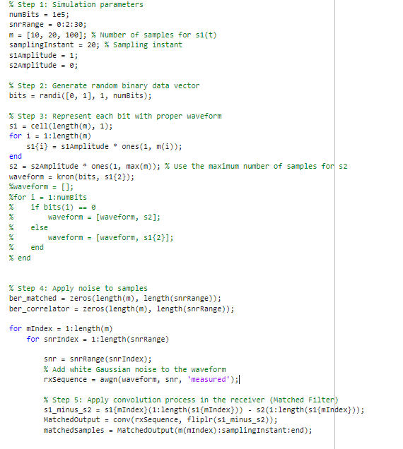

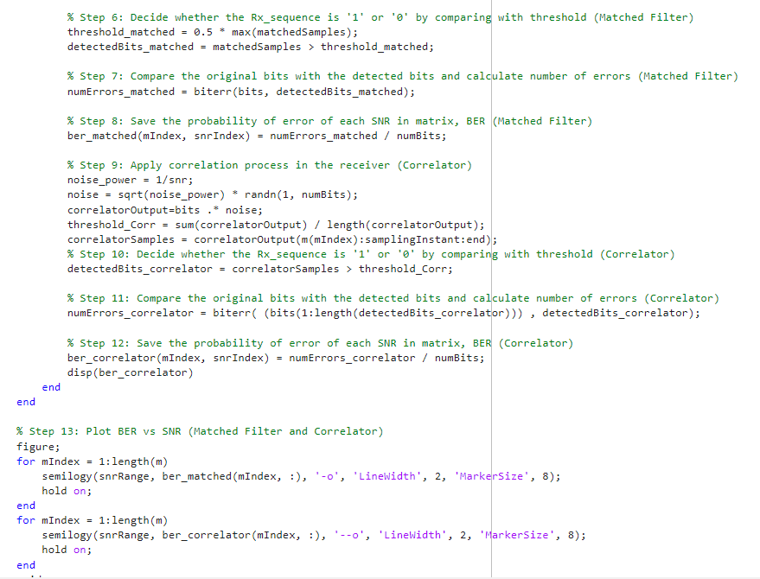

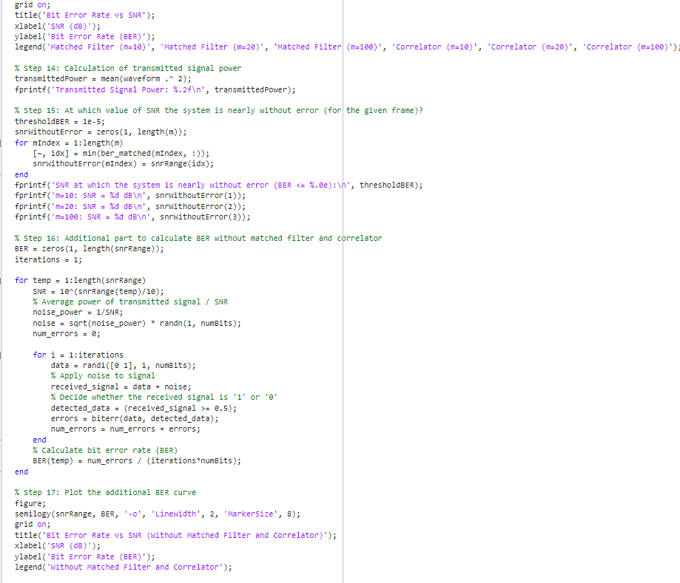

Output:

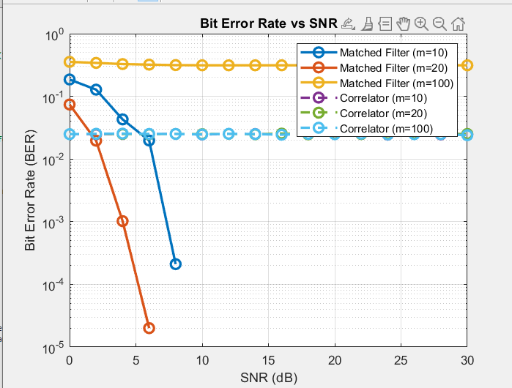

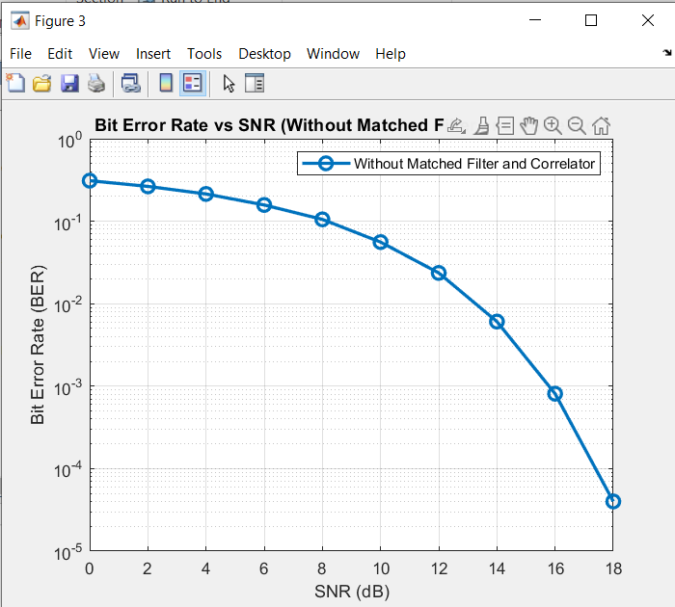

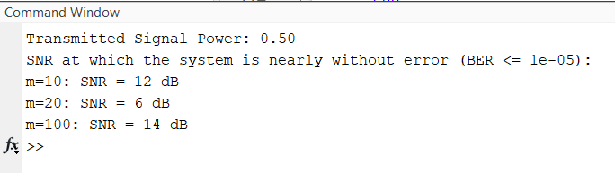

Comments:

Matched Filtering (MF):

Principle: Matched filtering is a technique that involves correlating the received signal with a known reference waveform, which is ideally the time-reversed and scaled version of the transmitted signal.

Operation: The received signal is convolved with the matched filter, which maximizes the signal-to-noise ratio (SNR) and enhances the detectability of the transmitted signal.

Benefits:

Improved detection: Matched filtering minimizes the effects of noise and interference by emphasizing the desired signal components.

Optimal for known waveforms: It is most effective when the transmitted signal is known, allowing for precise synchronization and detection.

Limitations:

Computational complexity: Matched filtering requires extensive computations, especially for longer signals, which may increase system complexity.

Signal design limitations: It relies on accurate knowledge of the transmitted signal waveform, which may not always be available or feasible.

Correlation-Based Detection:

Principle: Correlation-based detection involves comparing the received signal with a reference waveform without the need for exact synchronization or knowledge of the transmitted signal waveform.

Operation: The received signal is correlated with the reference waveform, and the correlation output is used for detection.

Benefits:

Reduced computational complexity: Correlation-based detection is computationally simpler than matched filtering as it eliminates the need for time reversal and scaling operations.

Robustness: It can handle cases where the exact transmitted signal waveform is unknown or not easily obtainable.

Limitations:

Performance trade-off: Correlation-based detection may have lower detection performance compared to matched filtering, especially in the presence of noise and interference.

Synchronization sensitivity: It is more sensitive to synchronization errors, as accurate alignment between the received signal and the reference waveform is crucial.

Comparison and Comments:

Matched filtering provides optimal detection performance when the transmitted signal is known and accurate synchronization is achieved. It is particularly useful in scenarios with low SNR and when the transmitted signal has a specific waveform.

Correlation-based detection offers a computationally simpler approach that does not require exact knowledge of the transmitted signal waveform. It can be more robust in cases where the transmitted signal characteristics are not precisely known.

Matched filtering generally outperforms correlation-based detection in terms of detection accuracy and noise rejection. However, it comes at the cost of increased computational complexity.

The choice between matched filtering and correlation-based detection depends on the specific requirements of the communication system, available signal information, and trade-offs between complexity and performance.

Part2:

Code: 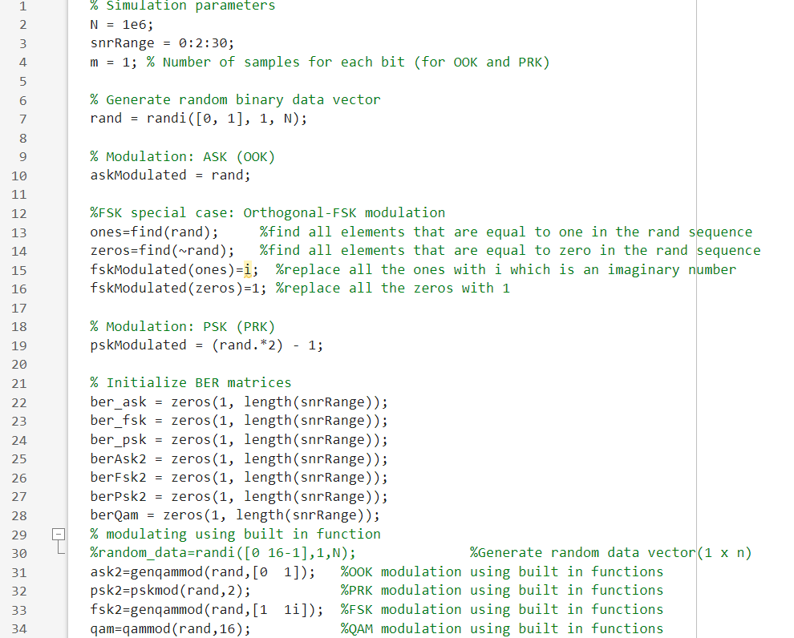

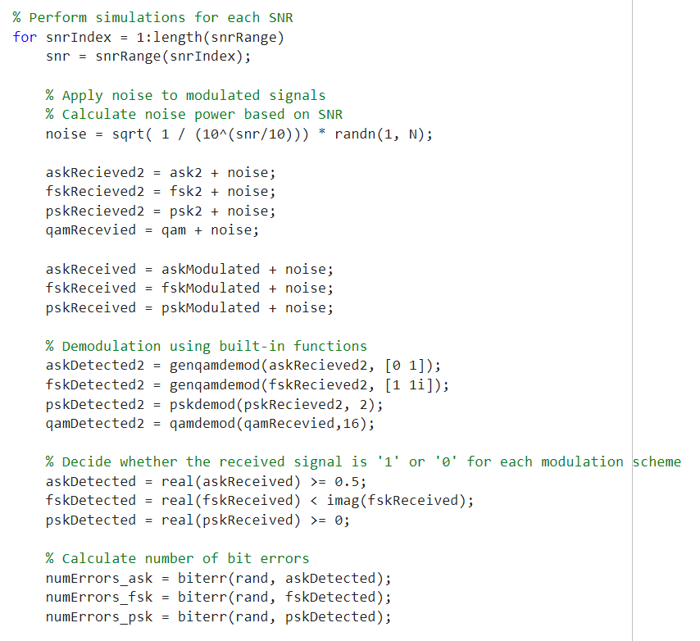

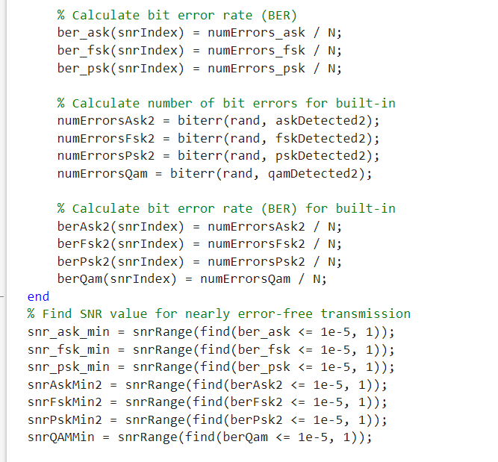

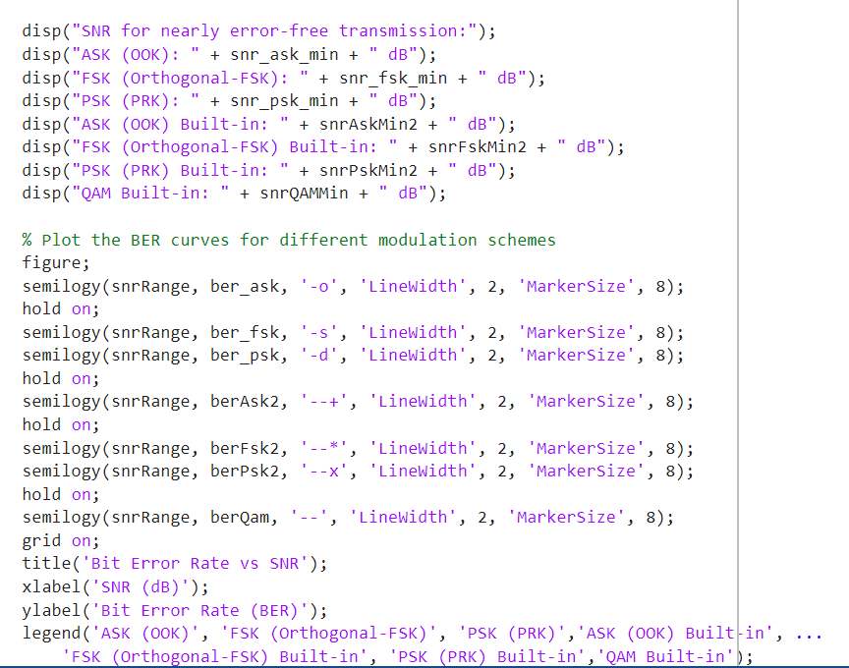

Output:

